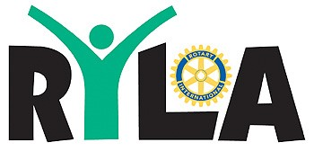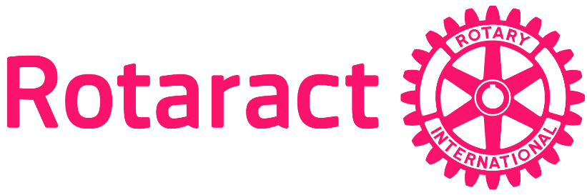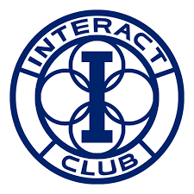

Rotary Youth Service Sponsor Form
Please make checks payable to ROTARY DISTRICT 6910
Name: ________________________________________________________
Company Name: ________________________________________________
Address:___________________________________________________________________________________________________________________
Email: ________________________________________________________
Phone Number: _________________________________________________
Sponsor Levels
_____Champion for Youth Level: $1,000
- Company logo on all the RYLA printed materials (t-shirts, water bottles, flyers, etc.)
- Recognition on both the district RYLA and Interact websites for the entire year: www.ryla6910.com and www.rotaryinteract6910.com
- An invitation for a brief presentation at the Interact district conference and RYLA youth leadership camp
- Recognition on all social media platforms
- An invitation to have a representative from your company or organization participate on the scholarship selection committee.
_____All for the future: $500
- Recognition on both the district RYLA and Interact websites for the entire year: www.ryla6910.com and www.rotaryinteract6910.com
- Company logo on all RYLA printed materials (t-shirts, water bottles, flyers, etc.)
- Recognition on all social media platforms
- An Invitation to attend our Interact District Conference and experience first-hand your resources at work
_____Stewards for the Kids: $250
- Recognition on both the district RYLA and Interact websites for the entire year: www.ryla6910.com and www.rotaryinteract6910.com
- Recognition on all social media platforms
- An invitation to attend our Interact District Conference and experience first-hand your resources at work.

_____Other________________________________________________________________

Please email your company logo to bobalman@yahoo.com
THANK YOU FOR YOU SPONSORSHIP AND SUPPORT!

